# Azure Runbook Website installation guide

**VERSION 1.0**

1. Download and install .NET Core Runtime 2.1 on the webserver:

<https://www.microsoft.com/net/download/windows>



1. Extract the zip fil and copy the folder to C:\inetpub on the webserver:

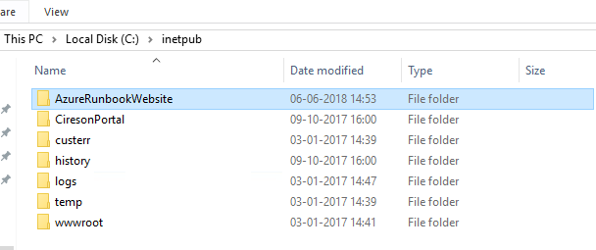

1. Open Internet Information Services and Add a new Website:

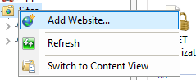

Choose name, location and and port (or optional create a host name if an A-record is made already)

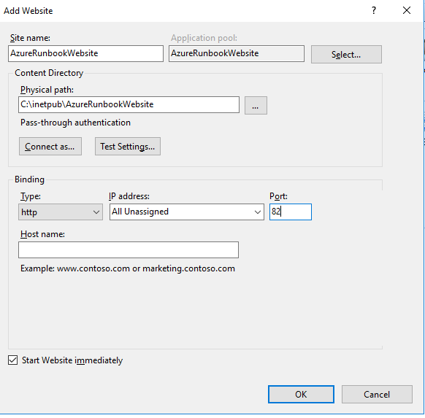

1. Go to Application Pool and Right-click the AzureRunbookWebsite -> Basic Settings

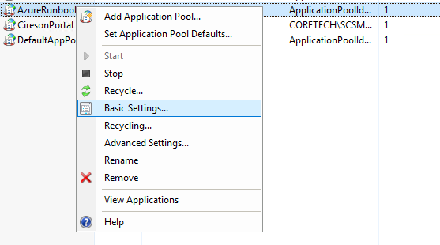

Switch from .NET to No Managed code:

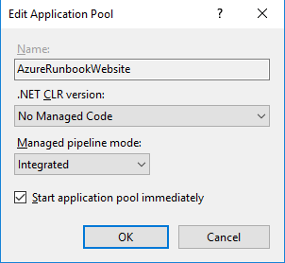

1. Test the website by clicking on the website and click Browse:

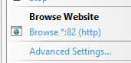

This should pop-up:

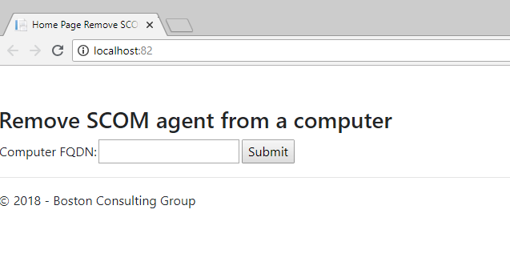

# Website configuration

1. Open C:\inetpub\AzureRunbookWebsite\appsettings.Production.json as Administrator
2. Change the the Webhook01 URL and optional the output success and fail message:

Ignore the other values for now, these are not used in version 1.0

